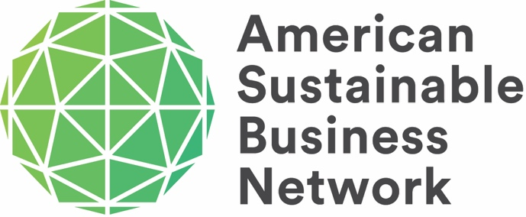
November 15, 2021
I am writing to inform you of exciting news about the merger of ASBC (formerly ASBI) and SVC, which going forward will be known as the American Sustainable Business Network (ASBN), a 501 C3. The Boards of both organizations approved the merger which is on-track to be finalized by the end of 2021. This follows a year-long strategic alliance during which the two collaborated closely to assess its benefits and impact. This will be announced publicly shortly, however, I wanted to make sure that you were aware of this now.
Collectively, ASBN, as the new organization will be known, has realized many of the anticipated benefits and also uncovered some unexpected ones in pursuit of creating the leading socially responsible business group in the U.S. The resulting collaboration will retain all staff, is a powerful force for environmental change, and social and economic justice at the federal, state, and local levels.
Given the strength and unique identity of each brand individually, the new organization will use the strongest aspects of each organization’s history, and in the case of SVC recognizing the organization’s origin as Social Venture Network. ASBN’s new logo incorporates aspects of each brand, and we will implement usage of the new logo during the fourth quarter of 2021.
As a key supporter, we want you to be among the first to know that the past 12 months of the strategic alliance between the two organizations have shown that by combining membership efforts, membership growth outpaced prior trends by more than double. A combined organization will be stronger, more resilient, and better able to thrive in challenging economic times. Other key benefits identified include:
- The combined board of directors brings even more expertise to support the organization’s bold visions, deeper expertise in operationalizing commitments to justice, equity, diversity, and inclusion, and a larger shared network create opportunities for collective aims.
- Each organization has some unique capabilities, such as ASBC advocacy and policy work, SVC conference and event planning, pitch events, and ASBC media communications and coalition building. A merger allows the combined organization to more fully deploy these capabilities for the benefit of the missions of both organizations and do even more for members and other stakeholders.
- A merger will save money and be more time efficient as there are several places where each organization duplicates work that will be combined with a single entity such as web management, marketing, social media, development of webinars, and accounting.
- ASBC and SVC have each found the last 12 months of the strategic alliance to be fruitful and productive, and a formal merger will realize - through economies of scale - accelerated growth along with increased member benefits, and a streamlined member experience.
- The size and quality of the combined membership improves the value proposition to prospective members, foundations, and sponsors, enabling revenue growth and organizational stability.
ASBC as a 501 C4 and SVC as a 501 C3 will continue to exist as separate legal entities that will be managed by the umbrella organization ASBN which will be the public-facing brand of the organization, employ staff, appoint the ASBC and SVC boards, and set priorities, budget, planning, etc. for the combined entity. The umbrella ASBN board will be initially composed of representatives from SVC and ASBC, but going forward the board will be selected without regard to prior affiliation. The bylaws of all the organizations are being revised and conformed so they work together seamlessly. An Executive Committee and other committees to carry out specific governing and planning tasks will be appointed shortly.
The mission and teams of each organization remain intact, however, there is now an umbrella structure to combine the best of both organizations. Each leader will guide their respective functions while continuing to collaborate and strengthen one another to accelerate their respective missions and increase collective power and influence. As we learned during the past year, they share the same values and will operate more efficiently together than separately.
Although it is not widely known, SVC and ASBC have a long-shared history. Established in 1987, what evolved to become SVC was one of the nation’s first and most influential peer organizations dedicated to demonstrating the ‘triple bottom line’ potential of valuing people, planet, and profit on equal footing. Through yearly gatherings, peer circles, and structured mentoring, SVC has provided inspiration for new ventures and helped incubate other key contributors to the social venture community including ASBC in 2009. Other notable organizations incubated by SVC include Businesses for Social Responsibility (BSR), Net Impact, Common Future, Investors’ Circle, and B Lab. ASBC was created to advance business advocacy and public policy to realize a sustainable and just economy. SVC and ASBC were born of the same entrepreneurial spirit and despite becoming independent organizations, the connection and mutual respect between the two remained strong.
The combined ASBN creates one of the most powerful entities to represent and advocate on behalf of a new form of capitalism which rejects a sole focus on short-term profits in favor of seeking long-term value and accounting for all stakeholders: owners, workers, families, community, environment, state, nation, and world.
Please join us in celebrating this important milestone in our journey to create a just and sustainable economy that is better for all people and our planet and as always thank you for your support.

All the best
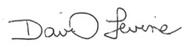
David Levine
President

