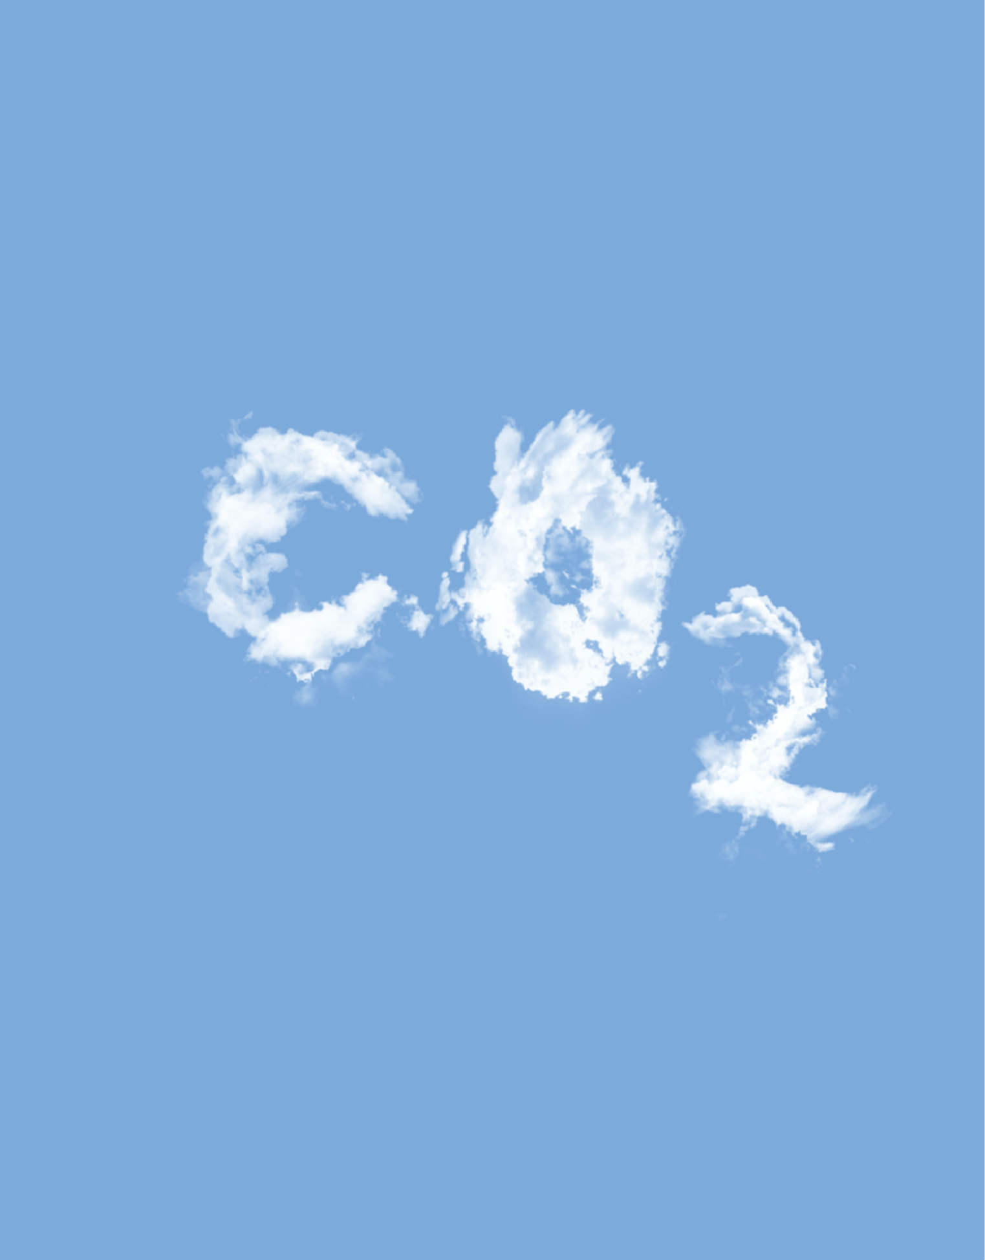
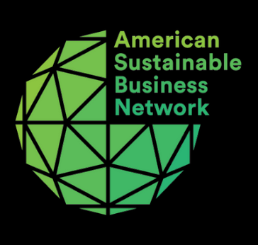
Business Case on

Carbon Labeling



Table of Contents
- Introduction
- Labeling Methods
- Business Case for Carbon Labeling

What businesses are doing right

Why it's beneficial to use carbon labels

9 Dangers to Human Health and Enviornment
10 Current Carbon Service Providers
13 Carbon Labeling Policy Background
16 Glossary
18 About ASBN

Report Authors: Jessica Chen, Liza Lamanna, and Michael Green, Contributions from: Abby Maxwell

Cover Image: Matthias Heyde
asbnetwork.org

ASBN | Carbon Labeling Business Case

Introduction

Carbon is the leading source of human-induced climate change, contributing to air pollution, ocean acidification, global temperature fluctuations, and more. By measuring, tracking, and reporting those emissions businesses can start to help the carbon reduction process by informing and empowering consumers to measure the impact of their lifestyle, allowing them to make informed purchasing decisions, as well as keeping businesses accountable for monitoring their emission rates. The public pressure to measure and label carbon has begun to incentivize companies to label their products and services, providing greater transparency to all stakeholders.

The American Sustainable Business Network’s (ASBN)’s Carbon Labeling Campaign's objective is to support policies that include carbon labeling and emissions transparency such as voluntary action and policy requirements. A carbon emission label or carbon label provides the consumer with a clear description of the carbon dioxide emissions created by or as a byproduct of a product. These can range from a general carbon neutral tag to something that resembles a nutrition label of the full life cycle emissions including as a by-product of manufacturing, transporting, or disposing of a consumer product. Currently, there is a lack of mandatory disclosure requirements but many businesses are opting to include voluntary disclosures (“soft laws”) in their business models. Voluntary regulations are rule structures for businesses to demonstrate emissions reductions beyond what the law requires of them. Whereas mandatory disclosure requires tracking and reporting by law, rules, or regulations. We will discuss further current voluntary disclosures and relevant policies later on in this business case. We believe that implementation of Carbon Labeling by businesses can make a major difference in our ability to identify and chose business practices and innovative processes and products that we help us meet our goals to address the climate crisis.
W

Labeling Methods

With the large variety of products beginning to share their emissions through carbon labels, there is also a large variety in how this information is presented. Three categories have emerged, a carbon-neutral label, a scoring system, or a numeric footprint.

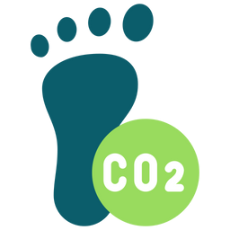
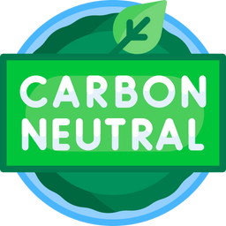
Carbon-neutral labels are utilized by businesses that have calculated their carbon footprint and have put offsets in place but don’t want to share the exact emissions. This demonstrates to consumers that reducing carbon emissions are a priority but does not convey a true communication of emissions levels.

Scoring system labels, often seen in Europe, use colors correlated to a number or a letter grade. This method is more detailed than the carbon neutral style and easily conceptualizes the actual emission but does not call out specific improvements that companies are making.

Numeric footprint labels demonstrate the actual emissions from the product and some even break it down by sector to show the underlying drivers of the emissions. This model resembles a nutrition label making it easy for consumers and government and institutiona purchasers to understand the full scope of the product and compare it with other products.

Business Case for Carbon Labeling

What businesses are doing right

More and more businesses and companies are proactively using voluntary carbon labels for their products. Carbon labeling has entered many product streams, ranging from technology, cosmetic, food, and apparel companies. The introduction of carbon labels can help consumers understand and track the impact of the products they are purchasing. Not only will carbon labels help consumers in tracking their footprint, but they also provide an opportunity to motivate companies to reduce the impacts of their products. Carbon labels summarize greenhouse gas emissions information on consumer goods in order to allow for consumer choices that may rapidly reduce emissions and therefore ease the threats posed by emissions to people and the planet. Promoting the use of carbon labels on products is seen as an affordable and viable option to reduce emissions and lessen the negative effects of carbon emissions. A recent article compares the growth in the use of carbon labels as similar to nutrition labels, “carbon labels are the new calorie.” Examples of the use of these labels range from the food and household products industry with Unilever, to the fashion industry with shoe company Allbirds.
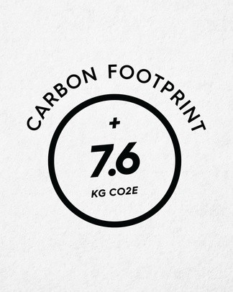
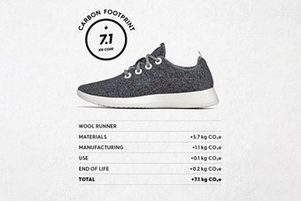
Figure 1 - name whose footprint this is
Figure 2 - name whose footprint this is



Why it's beneficial to use carbon labels
1
Labels build consumer trust
2
The market for environmentally and socially responsible products shows strong growth

3
Tracking and reporting of carbon footprint data is useful for companies to benchmark progress and find efficiencies

building consumer trust
1

Communicating and measuring environmental impacts builds trust with consumers and increases consumer climate literacy. Businesses that are transparent about their products (carbon or other metrics) can build trust with consumers in its business or product. Transparency in this area has the possibility to advance consumer climate literacy. The National Oceanic Atmospheric Administration of the US Department of Commerce (NOAA) defines climate science literacy as understanding individuals’ influence on climate and climate’s influence on people and society. Therefore, a climate literate individual would be able to make informed decisions based on how their actions will impact climate.


The consumer sentiment in the market has been shifting towards a more “green” and environmentally friendly market. A study by the European Consumer Organization showed that 57% of EU consumers are receptive to environmental claims when purchasing but 61% of consumers find it hard to understand how to make those more eco-conscious choices. More than 40% of consumers distrust what they hear about global warming from businesses while a further 50% do not know whether to believe corporate claims or not.

green product market growth
2

Consumer demand for environmentally and socially conscious products remains strong. Data shows that the public has the power to influence companies towards sustainable business practices. Between 2015 and 2019, sustainability-marketed products in the consumer packaged goods (CPG) market accounted for half of overall market growth, despite representing only 16% of the CPG market. This is largely driven by consumer demand, 85% of consumers stated that they would be more likely to buy from a company with the reputation of being sustainable than one that is neutral.. Sustainability marketed products grow 2.7x faster in their categories than conventionally marketed products.

With the rise of the conscious consumer, the market has dubbed those willing to change their behavior as Lifestyle on Health and Sustainability (LOHAS) consumers. These ethical consumers are typically more conscious about their social and environmental responsibility and are more willing to adjust their lifestyle, and change what they buy and consume to make an impact.

The current LOHAS market is valued to be a $355 billion market in the USA with an expected growth of 10% per year. Worldwide, the LOHAS market is valued to be $546 billion. In the United States, LOHAS consumers represent about 23% of the U.S. population. The growing interest in a company's sustainable business practices and products have blossomed into a new market for appealing to LOHAS consumers through transparency efforts. Transparency on topics such as packaging, safe or toxic chemicals, organic products, sustainability initiatives, working conditions, and supply chain information are favored by the LOHAS community. The need for transparency creates a space for measurable outcomes (like ratings) so that consumers can understand and decide which products and services align with their values. The future wellbeing of the planet is a top concern for consumers, especially younger generations. This relates to greenhouse gas emissions, as it is a method that is easily understood by and communicated to consumers.
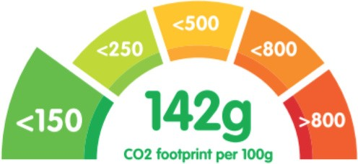
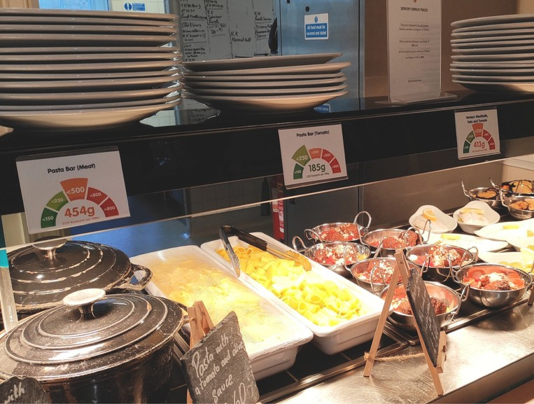

There is data to support that environmentally marketed products, specifically those that display carbon footprint labels, present a carbon emissions reduction of 4.7% per meal in the context of food products. That same study concludes that carbon labels are an effective tool to encourage increased sustainable food purchases by consumers.

tracking footprint data benefits
3

Tracking and reporting on impacts like carbon emissions are great for companies to benchmark progress, find efficiencies, eliminate waste, etc.
Carbon Labels can aid businesses in identifying and reducing waste in product streams. As companies begin to view their supply chain through an environmental lens, they can identify stages that contain high point sources of carbon emissions and aim to reduce emissions. Transparency and accountability throughout the entire supply chain will allow businesses to effectively consider their overall environmental impacts and make changes to lessen the carbon emissions. Labeling carbon can help businesses benchmark their products and services to others in the industry and monitor performance levels allowing for consumers to easily compare products. While much research is focused on the consumer side of emissions reductions due to the use of carbon labels, recent research found connections with business use of carbon labels to improved reputation among environmentally conscious consumers and inducing changes down the supply chain.


With the large amount of growth in the market for environmentally conscious businesses who are adapting these practices can attract unique investments as well as charge a premium. Sustainability-marketed products can command price premiums over their conventional counterparts that can range from 8% to 130%. The use of 3rd party verification (i.e. voluntary carbon labels) is currently a crucial component to transparency and accountability for investors and managers of sustainable funds. The use of carbon labels benefits consumers by preventing misleading claims and greenwashing, and investors who will have confidence that products and services are adhering to claims in regard to their environmental sustainability goals.

Dangers to Human Health and Evironment
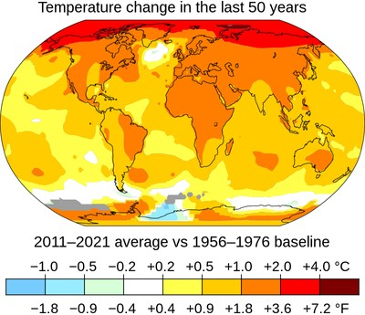
Implementation of carbon labeling will aid in consumer and business awareness of carbon levels in their everyday items. This increased awareness is the first step to reduce our climate impact as well as reducing our overall carbon emissions. Carbon has harmful effects on humans, including how exposure to carbon can lead to a wide variety of health complications such as difficulty breathing, elevated blood pressure, coma, asphyxia, convulsions and more. Potential health benefits of reducing or limiting carbon will include reduced dementia, cardiovascular disease, diabetes, obesity, breast cancer, colon cancer, and depression. It has been estimated that if global warming is kept under 2°C in the next 50 years, it can prevent up to 4.5 million premature deaths.

Environmental benefits due to reduced carbon levels are improved air quality, improved agricultural productivity, increased drought resistance and the slowing down of climate change impacts.
Carbon labeling can lead to reductions of these negative health and environmental effects due to the potential effects on behavior in response to labels. These changes in behavior can affect not only individual consumer choice, but additionally may incentivize businesses to lower carbon emissions throughout supply chains. Transparency will level the playing field.

Current Carbon Service Providers

Carbon service providers help businesses measure, manage and report carbon emissions across their operations and the value chain. Two internationally recognized standards have emerged, the BSI Publicly Available Specification 2050:2008 (PAS 2050), and the Global Greenhouse Gas protocol product standard (GHG Protocol). Most service providers use one of these methods to ensure thorough and complete calculations. Both include emissions from the collection of raw materials, to production, transportation, use, and disposal, helping to make the carbon footprints of goods and services comparable. The standards have the same key methodological rules because of cross-collaboration during development but have slightly different scopes and outcomes.
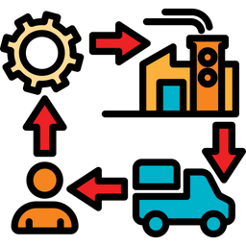
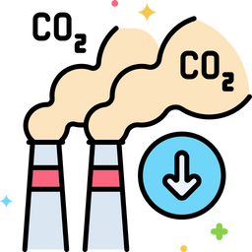

PAS 2050 was established in 2008 and revised in 2011 by BSI British Standards and co-sponsored by the Carbon Trust and the UK Department for Environment, Food and Rural Affairs (DEFRA) as a publicly available specification for the assessment of product life cycle GHG emissions. These requirements are used for recording emissions.

The Global Greenhouse Gas (GHG) protocol was established in 2011 by a collaboration of the World Resources Institute and the World Business Council for Sustainable Development. In addition to providing requirements to measure the GHG inventories of products, it also includes requirements for public reporting.

Reporting emissions are broken into three categories to reflect the source.

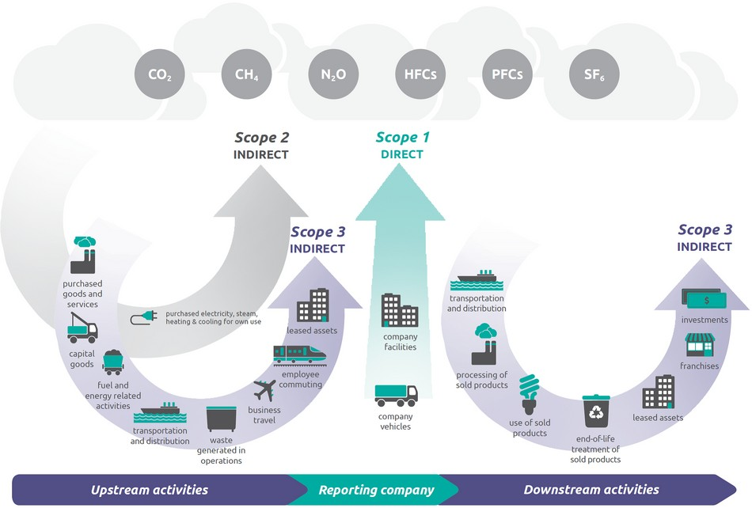

Emissions coming directly from activities or substances that are owned or controlled by the organization (e.g. fuel combustion in boilers, furnaces, vehicles).
Scope 1
Emissions from purchased sources of energy, such as electricity or heating. This is the largest category accounting for at least a third of global emissions.
Scope 2

Emissions from indirect sources of production or operations in the
supply chain.
Scope 3

Both GHG Protocol and PAS 2050 provide approaches to promoting the use and development of sector-specific rules – known as ‘product rules’ in the GHG Protocol and ‘supplementary requirements’ in PAS 2050.

PAS 2050 supplementary requirements include Sector Rules and Product Category Rules. The sector rules cover a wide range of areas from goods and services to seafood and aquatic food to fully capture the intricacies of different sectors. The Product Category was created so that there is consistency across products for easy comparisons.

GHG protocol establishes three corporate standards to aid service providers and businesses in determining more accurate emission levels for their specific industries. The corporate standard provides requirements and guidance for businesses preparing a corporate-level GHG emissions inventory. In addition to this standard, there is guidance specifically for the agricultural sector which has a unique set of challenges. The corporate value chain standard includes scope three emissions to allow companies to assess their entire value chain emissions impact and identify where to focus reduction activities. The product standard is used to understand the full life cycle emissions of a product and focus efforts on the greatest GHG reduction opportunities.

Carbon Labeling Policy Background

As described above, the current carbon labeling policy space is lacking actionable regulation. However, there are relevant policies that aim to reduce the overall carbon emission levels, which are important because of their potential to inform carbon labeling policies.

Federal Policy Initiatives

Catalyzing Clean Energy Industries and Jobs Through Federal Sustainability (Executive Order 14057): Sets a goal of achieving net-zero emissions from federal procurement by 2050. The EO established a federal Buy Clean initiative, a Net-Zero Emissions Procurement Federal Leaders Working Group, and a Buy Clean Task Force to provide recommendations on policies and procedures to expand consideration of embodied emissions and pollutants of construction materials in Federal procurement and federally funded projects.

Protecting Public Health and the Environment and Restoring Science To Tackle the Climate Crisis (Executive Order 13990): This January 2021 order aims to advance environmental justice by improving public health by focusing on science and ensuring clean air and water across the country. This includes improved estimates of the social cost of carbon. These estimates have been updated since by an Interim Technical Support Document by the White House Interagency Working Group on Social Cost of Greenhouse Gases (February 2021) and more recently by the EPA in a November 2022 supplemental report document (Docket ID No. EPA-HQ-OAR-2021-0317). The interim value identified by the Interagency working group is $51 per metric ton of CO2. EPA’s proposal quietly suggested that number be increased to
$190.

State Policy Initiatives
Colorado: HB21-1303 - Global Warming Potential For Public Project Materials signed into law July 2021. Potential for carbon reduction by pursuing the carbon "embodied" in public buildings and roads.
Requires the office of the state architect to establish a maximum acceptable global warming potential for specific categories of construction materials. (e.g. public projects like buildings, roads, highways, etc.)
Requires the Department of Transportation to develop policies to determine, track and record greenhouse gas emissions of the eligible materials used in public projects.

New York: Fashion Act Senate Bill S7428A – proposes that supply chain mapping, due diligence disclosure, impact disclosure, and impact reduction targets would be required to be publicly available while doing business in the state.
Fashion Act would apply to global apparel and footwear companies with more than $100 million in revenue doing business in New York
Fashion act requires the companies to disclose the amount of materials used (such as cotton)

Other Relevant Policies

Securities and Exchange Commission (SEC): The Enhancement and Standardization of Climate-Related Disclosures for Investors - Under this proposed rule, all publicly traded companies would be required to disclose their climate related risks in their financial reports, possibly including not only emissions from the company itself, but also emissions across the entire supply chain (Scope 3 emissions)

Environmental Protection Agency (EPA): Regulation Greenhouse Gas Reporting Program (GHGRP)- Facilities are generally required to submit annual reports under Part 98 if: GHG emissions from covered sources exceed 25,000 metric tons CO2e per year. (Not at a consumer level)

Voluntary Actions

Voluntary Actions are initiatives or policies that are not currently regulated by the state or federal government.

Buy Clean - a policy approach aimed at the construction sector, introducing low-carbon construction purchasing to reduce greenhouse gas emissions from governmental procurement contracts.
Buy Clean policies are spreading quickly, as Federal, State and Local policy programs are adopting the Buy Clean policies. The Blue Green Alliance is a point organization for the Buy Clean Campaign.

Federal: The Clean Futures Act (introduced in 117th Congress, 2021) includes language for a Buy Clean Program. The Biden Administration's Climate Action Plan has clean manufacturing programs and incentives as a part of the move towards transitions in industry to support climate action.

State: Buy Clean and Buy Fair pilot programs were written into the Climate and Energy Omnibus bill in Minnesota and signed into law in 2021. A material-specific variation of Buy Clean focused on low-carbon concrete incentives was introduced in New York State in 2020. In 2022, Buy Clean Oregon was signed into law. See here the BlueGreen Alliance tracker of more state-level Buy Clean legislation.

Local: Cities are adopting elements of Buy Clean, either by region or by material. Examples are in Portland, Oregon in 2019 for lower-carbon concrete procurement and in Marin County CA with the first embodied carbon building code.

CDP, Non-Disclosure Campaign: The objective of the campaign is to drive further corporate transparency around climate change, deforestation, and water security, by encouraging companies to respond to CDP’s disclosure request.
CDP supports companies, cities, and states “to measure and manage their risks and opportunities on climate change, water security, and deforestation”

Image Sources

Cover Page: Photo by Matthias Heyde

Page 3 : Photo 1 (left), Photo 2 (center), Photo 3 (right)

Page 4 : Photo 1, Allbirds on Instagram (left), Photo 2 (right) Page 5 : Photo 1
Page 7 : Photo 1, "Fig. 1 Carbon Footprint Label Design" (left), Photo 2, "Fig. 2 Experimental Design" (right)
Page 7 : Photo 1 (left), Photo 2 (right) Page 9 : Photo 1, NASA GISS
Page 10 : Photo 1, (left), Photo 2 (right)

Page 11 : Photo 1, WRI/WBCSD Corporate Value Chain (Scope 3) Accounting and Reporting Standard (PDF), page 5.

Glossary

a carbon footprint is historically defined as the total sets of greenhouse gas emissions caused by an organization, event, product or person.
Carbon Footprint

Although there is not one official definition of carbon Impact, we use this term to refer to the effects of increased carbon emission.
Carbon Impact

the social cost of carbon is an estimate, in dollars, of the economic damages that would result from emitting one additional ton of carbon dioxide into the atmosphere.
Social Cost of Carbon

Carbon Emission is the release of carbon compounds (such as carbon dioxide) into the atmosphere. When this term is used, it is oftentimes in reference to carbon dioxide emissions, which is a greenhouse gas. There are both natural (i.e. decomposition, ocean release and respiration) and human sources (i.e. burning of fossil fuels or production activities) of carbon dioxide emissions.
Carbon Emission

About the American Sustainable Business Network
American Sustainable Business Network (ASBN) is a movement builder in partnership with the business and investor community. ASBN develops and advocates solutions for policymakers, business leaders, and investors that support an equitable, regenerative, and just economy that benefits all – people and planet. As a multi-issue, membership organization advocating on behalf of every business sector, size, and geography, ASBN and its association members collectively represent over 250,000 businesses across our networks. ASBN was founded through the merger of the American Sustainable Business Council and Social Venture Circle. www.asbnetwork.org

Newsletter | LinkedIn | Twitter | Facebook | Instagram
Connect with ASBN

